ALLIANCE FOR CALIFORNIA TRADITIONAL ARTS AWARDS $200,000 TO SUPPORT THE LIVING CULTURAL HERITAGE OF THE STATE
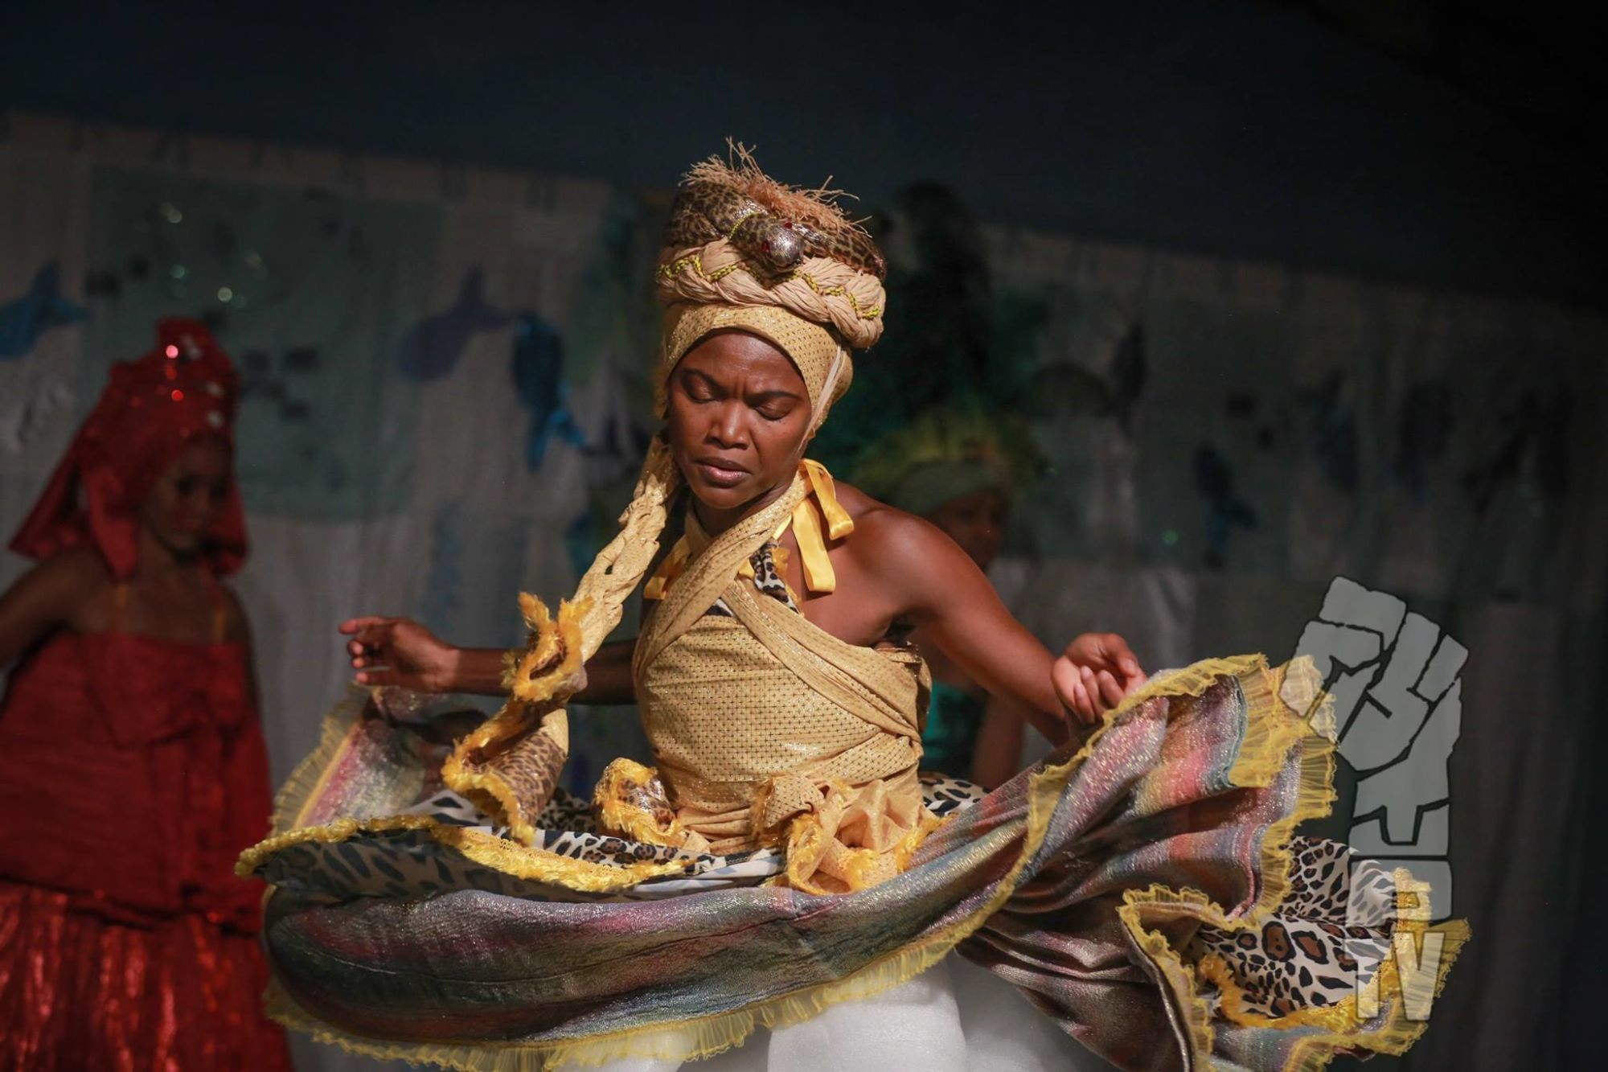
The Alliance for California Traditional Arts (ACTA) is awarding $200,000 to California nonprofit organizations to support folk and traditional arts. The annual Living Cultures grant supports cultural communities and Native California tribes engaging in traditional practices which include dance, music, material arts, foodways, storytelling and the sharing of indigenous knowledge through storytelling.
Since 2005, the Living Cultures grants have supported nearly 700 community-based projects, with more than $3.4 million in funding across 50 counties in California. This year’s cohort includes the promotion amongst Somali women in San Diego of Buran’Bur, a traditional art combining oral history, song, dance and costuming; a vibrant celebration of Romani music and dance in Sonoma county; and the transmission of indigenous Mixtec language and foodways via workshops in Fresno.
Artist Vera Passos performs Oxumare, the god of the rainbow, at BrasArte’s annual Yemanja Arts Festival. Photo: Eli Jacobs-Fantauzzi.
“California is on the leading edge of demographic change for the country,” says ACTA’s executive director Amy Kitchener. “These grants provide artistic resources to deepen cultural practices and strengthen the connections between communities,” Kitchener says. This year’s Living Cultures grants reach into many corners of the state, from Sonoma and Fresno counties to the urban centers of the greater Bay Area and Los Angeles.
A distinguished panel of cultural and community experts reviewed applications over a three-day period; ACTA board of directors approved the final grant selections. The Living Cultures Grants Program is supported by the Walter & Elise Haas Fund, The Flora & William Hewlett Foundation, and the Surdna Foundation, with additional support from the California Arts Council and the Los Angeles County Board of Supervisors through the Los Angeles Arts Commission.
The following California organizations will receive $5,000 Living Cultures awards:
- African Queens Dance Company, Oakland, Alameda County: Dance and Drums Workshops
- Ballet Folklórico Nueva Antequera, Los Angeles, Los Angeles County: A Day in Oaxaca Festival
- Bay Area Bomba y Plena Workshop, Oakland, Alameda County: Youth Bomba y Plena Workshop
- Berkeley Old Time Music Convention, Berkeley, Alameda County: Old-Time Bridges: West Virginia Connection
- BrasArte: The Damasceno Brazilian Cultural Exchange, Oakland, Alameda County: Yemanja Arts Festival 2019
- Chaksam-pa Tibetan Dance & Opera Company, El Cerrito, Contra Costa County: Kongpo Songbook
- Dance Group Xorotroptzi, Culver City, Los Angeles County: Xorotroptzi Annual Concert San Diego
- Dancing Ci(y)phers, Oakland, Alameda County: Hip Hop's Embodied Expression
- Ektaa Center, Irvine, Orange County: Ektaa Fest 2019
- El Teatro de la Tierra, Fresno, Fresno County: Teatro Inmigrante - Immigrant Theater
- Eszterlánc Hungarian Folk Ensemble, San Ramon, Contra Costa County: Eszterlanc Costume Project
- Frente Indigena de Organizaciones Binacionales (FIOB), Fresno, Fresno County: Transmitiendo el Conocimiento a Traves de la Lengua/Transmitting Knowledge through Language
- Great Leap, Inc., Los Angeles, Los Angeles County: FandangObon
- Hmong Association of Long Beach, Inc., Long Beach, Los Angeles County: Qeej Not Gangs Cultural Arts Program
- IIe Orunmila Afedefeyo, Los Angeles, Los Angeles County: Annual Egungun Jagun Masquerade
- Japanese Cultural Fair, Santa Cruz, Santa Cruz County: Japanese Cultural Fair
- JC Culture Foundation, Artesia, Los Angeles County: Lion/Dragon Dance/Drum Solo Workshop
- Kalingafornia Laga, Castro Valley, Alameda County: Manlaga Tako! (Let us Weave Together!)
- Kinnara Gagaku, Los Angeles, Los Angeles County: Kinnara Gagaku
- KlezCalifornia, Inc., Berkeley, Alameda County: Klezmer Workshops in San Francisco
- KSTARPRODUCTIONS, Oakland, Alameda County: The Black Choreographers Festival: Here & Now
- La Ultima Parada, San Jose, Santa Clara County: La Ultima Parada: A Celebration on the Day of the Dead
- Little Manila Rising, Stockton, San Joaquin County: Rondalla Music Training
- Manilatown Heritage Foundation, San Francisco, San Francisco County: Kommunity Kultura
- Network of Myanmar American Association, Monterey, Los Angeles County: Traditional dance classes and performance for youth
- North American Guqin Association, Union City, Alameda County: Memories of Old Guqin Masters
- Omnira Institute, Oakland, Alameda County: Roots of Faith, Roots of Freedom
- Purple Silk Music Education (PSMEF), Oakland, Alameda County: Traditional Cantonese Music Project
- Ravi & Shashi Bellare Arts Foundation, Chino Hills, San Bernardino County: Festival of Tabla
- Regional Organization of Oaxaca, Los Angeles, Los Angeles County: Creatividad Sin Limites/Creativity Without Limits
- Rhythm Arts Alliance, Los Angeles, Los Angeles County: African Drumming & Dununba Festival
- San Francisco Guzheng Music Society, San Francisco, San Francisco County: 2019 Annual Concert
- Senderos, Santa Cruz, Santa Cruz County: Connecting to our Roots: Mexican Traditional Dance and Music
- Somali Youth United, Inc., San Diego, San Diego County: Back to our Roots "Dib Ugu Noqosho"
- The Latino Commission Central Valley Nuevo Comienzo, Orosi, Tulare County: Orgullo Regional Project
- The VA'V Ensemble, Fremont, Alameda County: Vietnamese Traditional Music Workshops
- Theatre of Yugen, San Francisco, San Francisco County: Kyogen Costume Workshop
- Ukrainian Art Center, Inc., Los Angeles, Los Angeles County: Heritage Days
- Umoja Ensemble of the Inland Empire/ “We the People” Cultural Dance Center, San Bernardino, San Bernardino County: Inland Empire's Annual Ultimate Doundounba Festival 2019
- Voice of Roma, Sebastopol, Sonoma County:22nd Annual California Herdeljezi Roma Festival
CONTACT
Julián Antonio Carrillo
Program Manager, ACTA jcarrillo@actaonline.org| Phone: 415-346-5200
Read more about our grantees here.

